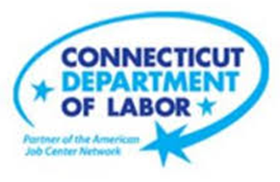

**NEW WEEKLY JOB POSTINGS FROM   
HELP WANTED ONLINE  
Office of Research**

**Week Ending August 6th, 2022: New Ads Up 11% Over The Week To Series High of 12,363**WETHERSFIELD, August 12th, 2022 – During the week ending August 6th, there were 12,363 new postings, up 1,223 new ads or +11%% over the week. Employers with large over the week increases include Yale-New Haven Health System (+169 new ads), Fidelity Brokerage Services (+92 new ads), and CVS Health (+83 new ads). Occupations with the largest over the week increases include Heavy & Tractor-Trailer Truck Drivers (+174 new ads), Childcare Workers (-85 new ads), Statisticians (+80 new ads), and Pharmacists (+80 new ads). This recent week of new ads is the highest on record, narrowly surpassing the previous high of 12,336 that occurred the week ending May 7th, 2022.   
  
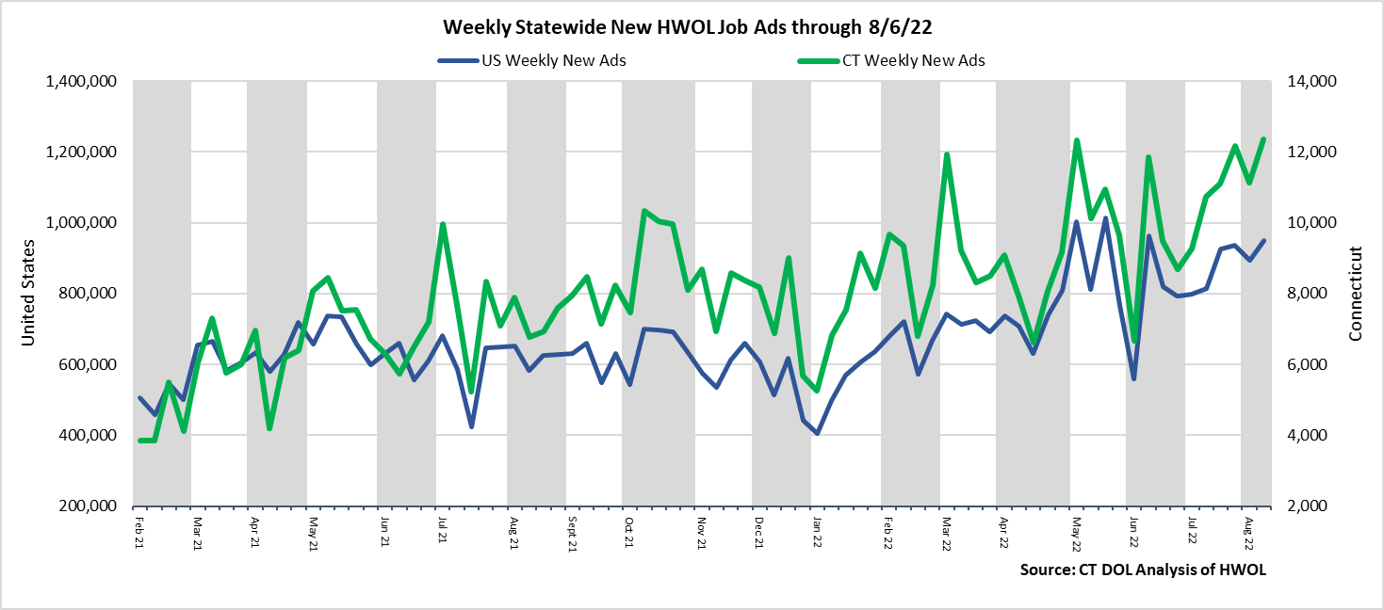  
**Industries** with the most new postings include Health Care & Social Assistance, Finance & Insurance, and Retail Trade.

**Occupations** with the most new postings include Registered Nurses, Retail Salespersons, and Heavy & Tractor Trailer Truck Drivers.

**Employers** with the most new postings include Yale-New Haven Health System, PricewaterhouseCoopers, and CVS Health.

**The three industries with the most new job postings were:**

* **Health Care & Social Assistance** (2,633 new postings, -1% over the week)
* **Finance & Insurance** (1,125 new postings, +25% over the week)
* **Retail Trade** (1,124 new postings, +23% over the week)

  
 During the week ending August 6th, 2022, the total ad increase of 1,223 new ads or +11% is the net result of increases in 14 of 21 industries. Half of the weekly increase occurred in three industries: Finance & Insurance (+227 new ads), Retail Trade (+213 new ads), and Transportation & Warehousing (+156 new ads). Some of the largest percent increases include Real Estate (+78% or +100 new ads), Transportation & Warehousing (+60% or +156 new ads), and Information (+41% or +95 new ads). During this week of overall gain, 7 industries had new ad decreases. These ranged from a 15 ad decline in both Pro., Sci., & Tech. Services and Health Care & Social Assistance, to a 60 ad decline in Arts, Entertainment, & Recreation.  
  
 For more information on total job ads by industry for Connecticut and its labor market areas, see the monthly report available here: <https://www1.ctdol.state.ct.us/lmi/hwol.asp>

**New Job Postings by Occupation** 

**The occupations with the most new postings were:**

* Registered Nurses (516 new postings, -28% over the week)
* Retail Salespersons (342 new postings, +22% over the week)
* Heavy and Tractor-Trailer Truck Drivers (279 new postings, +166% over the week)

**Employers with the Most New Job Postings**

Employers with the most new job postings during the week were mostly in Healthcare & Social Assistance, Finance & Insurance, and Retail Trade. The 25 employers shown above account for 18 percent of all new ads. 20 of 25 employers in the top 25 had over the week increases. The largest increases in the top 25 include Yale-New Haven Health System (+169 new ads), Fidelity Brokerage Services (+92 new ads), and CVS Health (+83 new ads). The largest decreases over the week include Hartford Healthcare (-203 new ads) and Deloitte (-137 new ads). Over four weeks, 24 employers in the top 25 had increases, the only decline was at Deloitte (-177 new ads). The largest four week increases occurred at Yale-New Haven Health System (+295 new ads) and PricewaterhouseCoopers (+127 new ads).  
  
**What is HWOL?**The **Conference Board Help Wanted Online**® Data Series (HWOL) measures the number of new, first-time Online job postings and jobs reposted from the previous month for over 16,000 Internet job boards, corporate boards and smaller job sites that serve niche markets and smaller geographic areas. To view more HWOL data, go to: <https://www1.ctdol.state.ct.us/lmi/hwol.asp>